FOODPRINTS: A Zomato Restaurant Analytics Web App

# 1. Introduction

The food delivery industry has experienced rapid digital transformation, and platforms like Zomato generate massive amounts of data related to customer preferences, restaurant performance, and food trends. Analyzing this data is crucial for understanding consumer behavior and optimizing business decisions. FOODPRINTS is a data-driven web application that provides insights into restaurant operations using visual analytics. The project aims to help users, analysts, and stakeholders gain meaningful insights from Zomato data through an interactive and user-friendly dashboard built with Streamlit.

# 2. Objective

The core objective of FOODPRINTS is to transform raw restaurant data into actionable insights. The application achieves this by offering:  
- A visual comparison of online and offline ordering behavior.  
- Identification of top-performing restaurants in terms of orders and revenue.  
- Popular cuisine tracking to understand food trends.  
- Sentiment analysis from customer reviews to assess satisfaction levels.  
- Interactive data filtering and exporting capabilities for business analysis.  
The tool serves as a foundational framework that can be expanded to support real-time analytics and predictive modeling.

# 3. Technologies Used

|  |  |
| --- | --- |
| Component | Technology |
| Language | Python 3.x - primary language used for data processing and scripting. |
| Framework | Streamlit - for building the interactive web dashboard. |
| Data Viz | Matplotlib, Folium, WordCloud - for static and interactive visualizations. |
| NLP | TextBlob - for performing sentiment analysis on textual review data. |
| Deployment | Localhost for development; optionally hosted on Streamlit Cloud. |
| Data Format | CSV - used as input format for metadata and review information. |

# 4. Features

The FOODPRINTS application includes the following core features:  
  
📊 Order Type Analysis: Understand whether customers prefer ordering online or offline.  
🏆 Top Ordered Restaurants: Identify the most frequented restaurants by number of ratings.  
🍜 Popular Cuisines: Visualize the most common cuisine types to detect food trends.  
💰 Revenue Estimation: Estimate restaurant profits using a calculated revenue model.  
🧠 Sentiment Analysis: Analyze textual reviews to determine overall customer sentiment.  
☁️ Word Cloud: Generate a word cloud based on frequent review terms.  
🗺️ Map View: Display restaurant locations interactively using latitude/longitude (if available).  
📥 CSV Export: Allow users to download filtered data for further use.

# 5. Project Structure

The project is organized into modular components:  
FOODPRINTS/  
├── app_pro.py # Main Streamlit application  
├── data/  
│ └── zomato.csv # Restaurant metadata and reviews  
├── requirements.txt # List of all dependencies  
└── assets/ # Optional static assets such as logos or icons  
This structure ensures maintainability and ease of expansion.

# 6. Core Code Concepts

- Streamlit: Used for creating a user interface with filters, buttons, and visual outputs.  
- Pandas: Essential for loading, cleaning, and manipulating data.  
- Matplotlib/Seaborn: Used to render static visualizations like bar charts and pie charts.  
- Folium + streamlit-folium: To embed interactive maps showing restaurant locations.  
- TextBlob: To compute polarity and subjectivity from review text.  
- WordCloud: To create a visual cloud of the most frequent review words.

# 7. User Interface

The user interface is clean and intuitive, designed using Streamlit widgets and layout options.  
- A sidebar offers filter options such as area, cuisine, and price range.  
- Main screen displays dynamic charts based on user selection.  
- Pie charts, bar charts, and word clouds enhance the visual experience.  
- Interactive elements like maps and downloadable buttons improve usability.

# 8. Styling

Styling is kept minimal and clean to prioritize clarity and focus:  
- Streamlit's default themes with emoji-based headings.  
- Icons and color schemes are used to distinguish visual components.  
- Word cloud provides an engaging and aesthetic touch.  
- All charts maintain readability through consistent font and color scales.

# 9. How to Run

To run the FOODPRINTS application locally:  
1. Ensure Python 3.x is installed.  
2. Install required packages using:  
 pip install -r requirements.txt  
3. Run the app using Streamlit:  
 streamlit run app_pro.py  
4. Open your browser and go to http://localhost:8501 to view the app.  
Optional: Upload to Streamlit Cloud for public access.

# 10. Screenshots

i)Footprints Dashboard

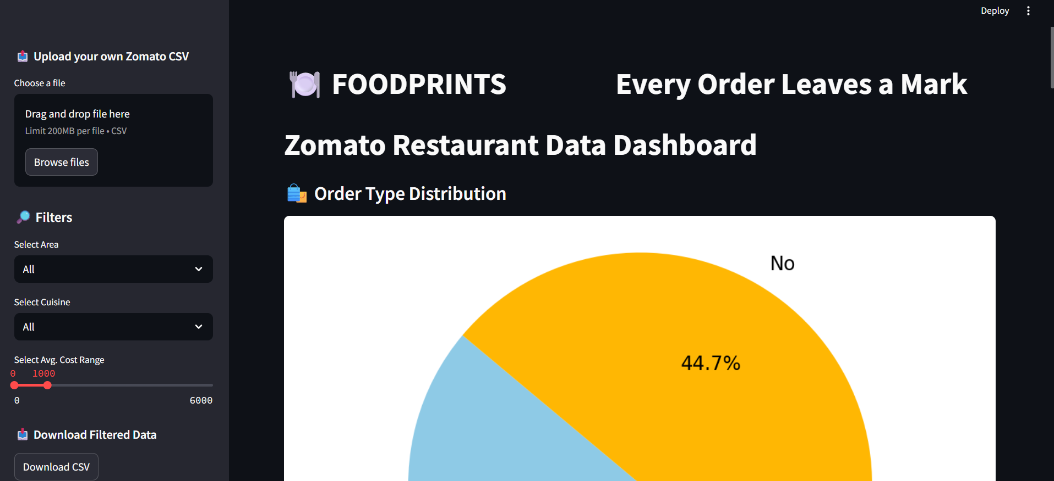

ii)Filter Segment

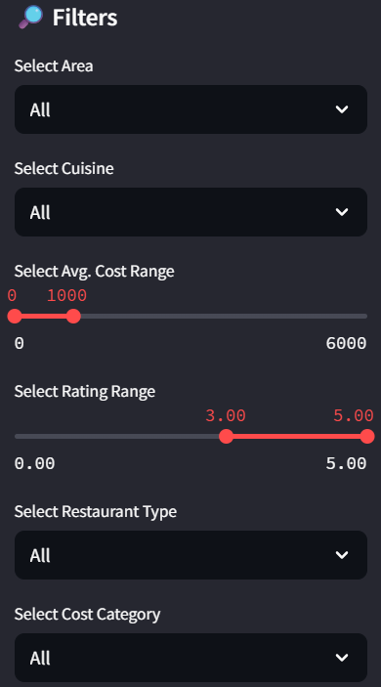

iii)Download Data Segment

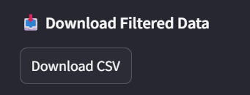

iv)Order Type Chart

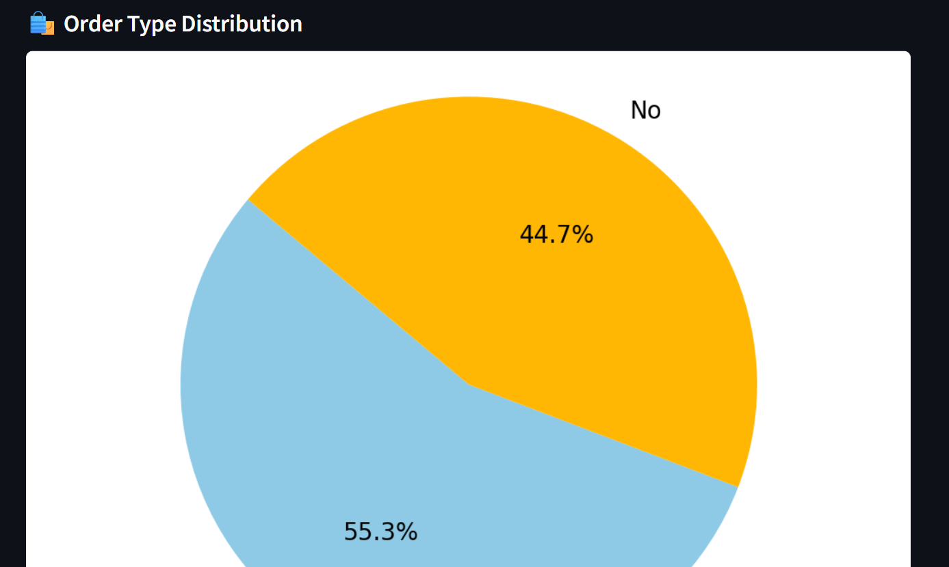

v)Top Ordered Chart

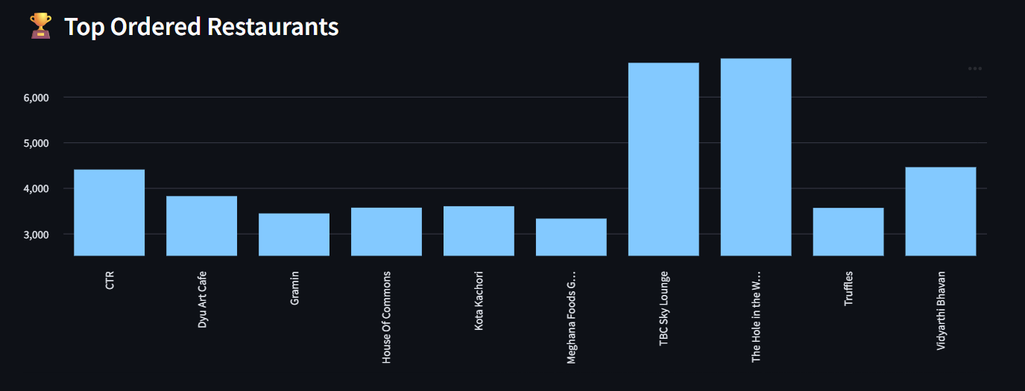

vi) Most Ordered Cuisines

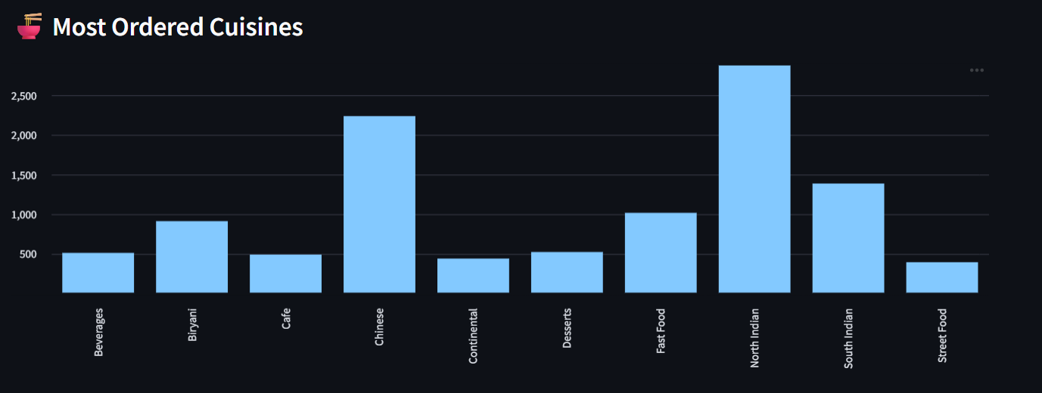

vii)Top Profitable Restaurants

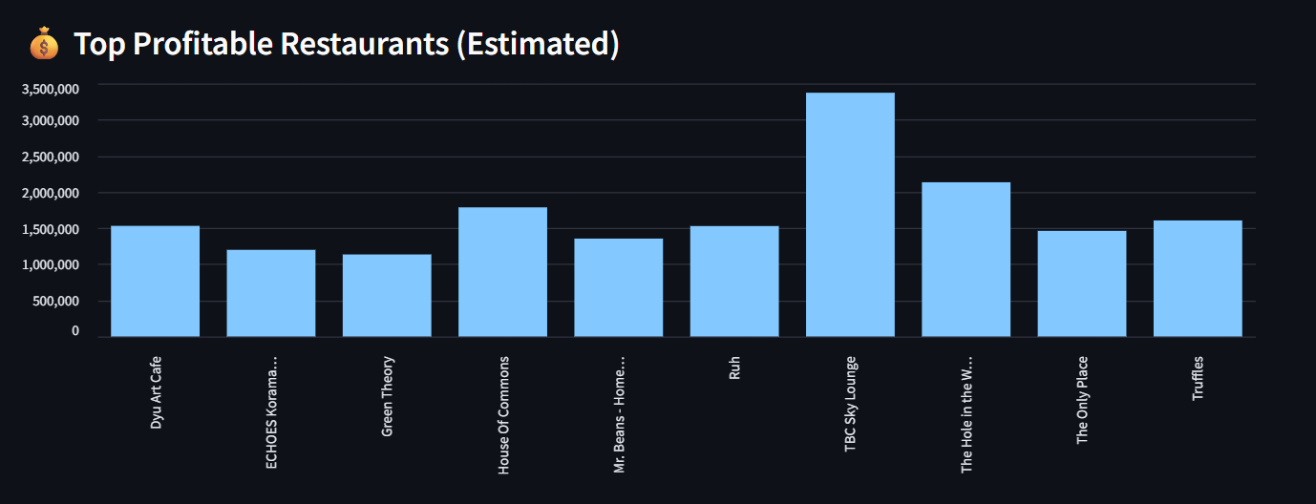

viii)Footprints Dashboard

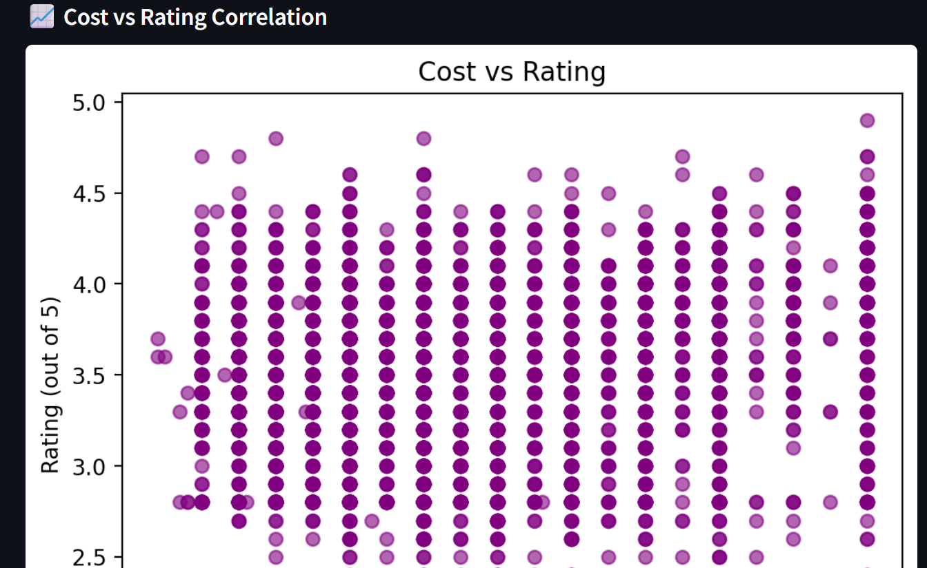

# 11. Conclusion

FOODPRINTS provides a powerful demonstration of how data visualization and simple machine learning techniques can be leveraged to generate insights in the food delivery industry. Through interactive filters, engaging charts, and customer sentiment analysis, it enables both technical and non-technical users to explore restaurant data effectively. Its modular design allows for future expansion into real-time analytics, predictive forecasting, and business recommendation systems.